**ENG1091 Linear Algebra Revision**

**I. Systems of Linear Equations**

**1.1 Augmented form**



**Pivot**

The leading non-zero coefficient of each row in echelon form

**1.2 Row echelon form (upper triangular form)**

 

- The pivot of each row has zeros below it.

- The pivots of following row are located in columns further to the right

- Any rows which have no pivot (i.e. rows consist all zeros) must come last

**1.3 Free variable**



For a system with infinite solutions, the non-pivot variable *z* is said to be a free variable and can be use as a parameter





This represents a straight line

**II. Consistency of Linear Equations**

**2.1 Consistency**

A linear system has **no solutions** is called **inconsistent**

In its row echelon form, there will be at least one row where all entries left of the partition are zero and the right most entry is non-zero



**2.2 Overdetermine and underdetermine**

Overdetermine means a systems has more equations than unknowns, so there can be a unique set of solutions. However, it ***does not guarantee consistency*** of the system.

Underdetermine means a system has less equation than unknowns, so unique solutions are impossible

**III. Matrices**

**3.1 Multiplication**

Two matrices A and B can be multiplied only the number of columns in A equals the number of rows in B.

If A is a m*p matrix and B is a p*n matrix, then AB is a m*n matrix.

To find the ij entry in the product AB, we multiply the entries along the ith row of A pairwise with entries on the jth column of B and add those pairs of products together.



**3.2 Transpose**

The transpose is obtained by interchanging its rows and columns. That is, the entries of the ith row become the entries of the ith column

- Property

$${(AB)}^{T}=B^{T}A^{T}$$

**3.3 Inverse**

The inverse of a ***square*** n*n matrix A is an n*n matrix B, such that AB = BA = I where I is the n*n identity matrix.

If A has an inverse, we say A is ***invertible or non-singular***

**Gauss-Jordan elimination**

Forming the augmented matrix consisting of A and I, and applying row operations until A becomes I. Correspondingly, I will have become A-1.



Stage 1

Perform Forward Gaussian elimination on [A|I] to reduce A to echelon form U. Also, make the pivot entries to be 1. Note if there is ***zero*** *in the diagonal entries*, then A-1 does not exist

Stage 2

Perform Backward Jordan elimination *starting with the* ***bottom pivot*** of U, bringing [U|I] to [I|B]

**Inverses of 2*2 matrices**



**Solution to Ax=B**

If **A-1 exists**, then **x=A-1B**

**Theorem**

The inverse of a matrix ***exists*** if and only if the determinant is ***nonzero***.

**3.4 Rank, Trace and Special Matrices**

**Rank**

The rank of a matrix A is the maximum number of linearly independent column/row vectors of A.

Rank can be found by ***echelon form****: the number of rows/columns that* ***do not consist of all-zeros*** *is the ranks*

(Rank=2)

Column rank and the row rank are always equal

**Trace**

The trace of an n-by-n square matrix A is defined to be the sum of the elements on the main diagonal (the diagonal from the upper left to the lower right) of A

**Symmetric Matrices**

A symmetric matrix is a square matrix that is equal to its transpose:

$$a_{ij}=a_{ji}$$

and A+AT is a symmetric matrix

**3.5 Determinant**

Determinant can be used in Cramer’s rule to solve linear equations, determine the existence of inverse of a matrix and determine the rank.

**3.5.1 2*2 Determinants**



A-1 exists only if **det(A) is not zero**

**3.5.2 Cramer’s rule**

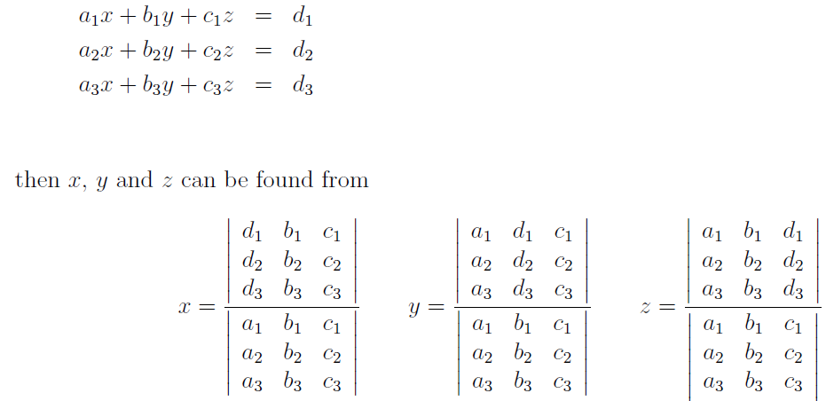

Cramer’s rule can be used only the denominator is not zero

**3.5.3 Larger Determinants**

- Sign Matrix: used along with cofactors



**Example**





-1, 4, 5 are cofactors. This method is called Laplace expansion or cofactor expansion

**3.5.4 Homogeneous systems**

A homogeneous system (i.e. AX = 0) always has the trivial solution x = 0. If the determinant of a homogeneous system is **zero** (which means A-1 does not exist), the system must have **infinitely many solutions**. If A-1 exists, the system has a trivial solution x=0.

For a non-homogeneous system (Ax = b), if **det (A) = 0**, then it has either **no solution or infinitely many solutions**.

|  |  |  |  |  |
| --- | --- | --- | --- | --- |
|  | det (A) | Inverse A (if **A is square**) | Full Rank | Solutions |
| Ax = 0 | 0 | Not exist | No | Infinitely many |
|  | non-zero | Exist | Yes | X = 0 |
| Ax = b | 0 | Not exist | No | No solution or infinitely many |
|  | non-zero | exist | Yes | - |

* **Only square matrices have inverse**

**3.5.5 Determinant and Rank**

If the determinant is zero, then the matrix is not full rank. If the determinant is not zero, rank can be determined by echelon form

**3.5.6 Properties**

- Interchange Property: Swapping any two rows or columns, changes the sign of the determinant



- Elimination Property: Adding a multiple of a row to another row does not alter the determinant



- Matrix multiplication property



If A is invertible, then



**3.6 Eigenvalues and eigenvectors**

**3.6.1 Definition**

Let A be an n*n matrix and x be an n*1 vector. Any scalar $λ$ satisfying $Ax=λx$ for some non-zero x is called an eigenvalue of A. The corresponding non-zero vectors x are called the eigenvectors of A corresponding to $λ$

**3.6.2 Find Eigenvalue**

Solve for $λ$

$$det\left(A-λI\right)=0$$

det(A-λI)=0 guarantees that the homogeneous system $\left(A-λI\right)x=0$ has infinitely many solutions

**3.6.3 Find Eigenvectors of eigenvalue**

Substitute the eigenvalue $λ$ to the equation $\left(A-λI\right)x=0$, and solve for x (using **Gauss’s elimination**). Eigenvector can***not be all zeros***.

**3.6.4 Properties**

The sum of the eigenvalues of A is equal to the sum of the elements of the diagonal of A

The product of the eigenvalues of A is equal to the determinant of A

**Terms**

Row echelon form

Laplace expansion

Augmented form

Pivots

Consistency of a matrix

Singularity

Transpose

Trace

Rank

Determinant

Cramer’s rule

Homogeneous system

Eigenvalue

Eigenvector